Hello there!

**Query 1)** As you can see, on the left hand side of the client-side screen, there are filters for instance **location**, **rate**, **years of experience**, **certifications**, etc.

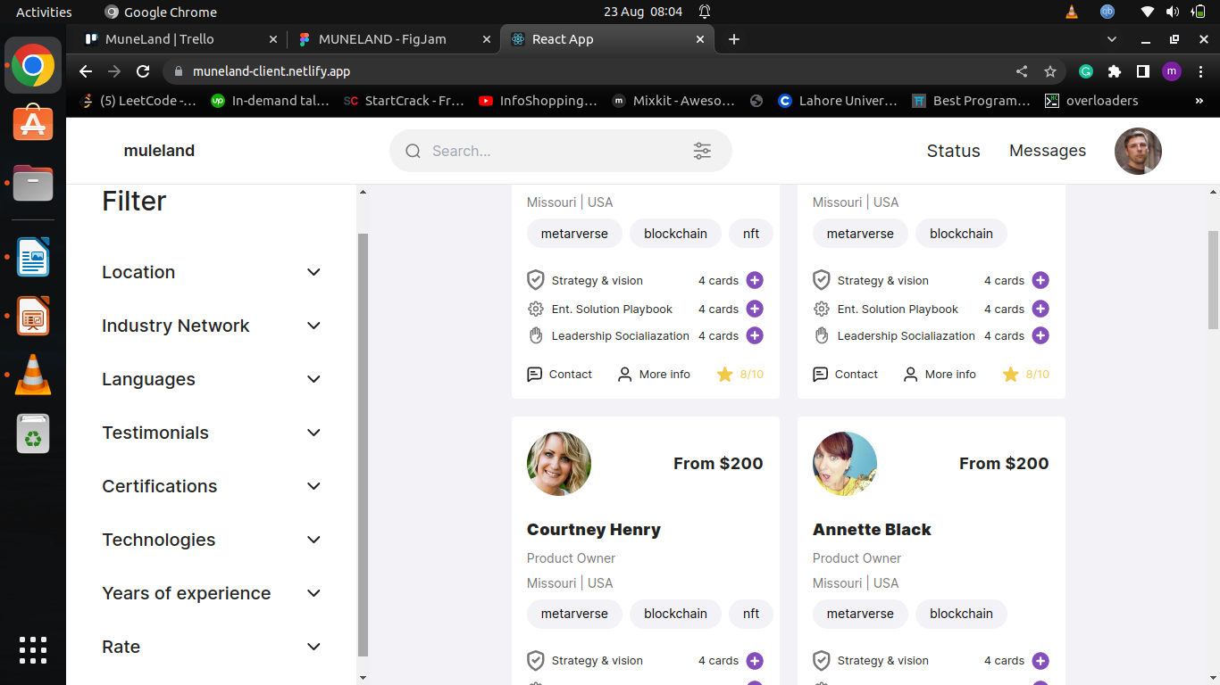

Many of these filters will NOT work as of now. These are the personal details of the freelancer. However, many of these details for example **years of experience**, **location**, **languages** etc are not saved on the freelancer side during their **SIGNUP** or later in **PROFILE** section where freelancer can edit their other personal details. Either the front-end of these components are missing on freelancer-side or something else. As of now these filters on the client-side will not work UNLESS we save all missing personal details like **language**, **technologies**, **years of experience**, **location** etc, on the freelancer-side 🡺 yes you’re right. Please save then all the these details on the freelancer side during their signup. And the day a freelancer changes/modified his personals information, we taking them in account in the filters

**Query 2)** I want to suggest a better way to implement the special card. The special card defines scope of the custom project depending on the requirements of the **CLIENT**.

In the current flow of the website, the freelancer makes a special card and send it to the client. However this might not be a better approach in my opinion because according to the flow of the website, the clients can view the freelancers (just like in FIVERR) but the freelancers cannot view the clients unless they are in contact through CHAT feature. This means that special card cannot be sent to those clients who are **not** in contact with the freelancer.

Might I suggest a more better approach? Because the scope of a custom project depends on the requirements of the **CLIENT**, the special card should be present on the client side of the website. This means that client will make a special card and send it to the freelancer. 🡺 **You’re right. I give you my confirmation to do like you suggested**

In this way more special cards can be sent over this freelancing platform. This will not only attract more clients, but also generate more revenue on the platform.

Let me know Thank you.